Sources of all images, including copyright or license requirements
1.hands https://www.google.com/url?sa=i&url=https%3A%2F%2Fwww.bondigym.com.au%2F&psig=AOvVaw00YLp5kj97pqsgAIWAQPDm&ust=1631109413523000&source=images&cd=vfe&ved=0CAsQjRxqGAoTCOi_86KC7fICFQAAAAAdAAAAABC7Ag
Licence: CCO Public Domain

2.male_personal_trainere https://www.google.com/url?sa=i&url=https%3A%2F%2Fbacktobasics4lifefitness.com.au%2Fpersonal-gym-trainer-melbourne%2F&psig=AOvVaw00YLp5kj97pqsgAIWAQPDm&ust=1631109413523000&source=images&cd=vfe&ved=0CAsQjRxqGAoTCOi_86KC7fICFQAAAAAdAAAAABCzAg
Licence: CCO Public Domain

3.man_ropes https://www.google.com/url?sa=i&url=https%3A%2F%2Fgymplus.com.au%2F&psig=AOvVaw00YLp5kj97pqsgAIWAQPDm&ust=1631109413523000&source=images&cd=vfe&ved=0CAsQjRxqGAoTCOi_86KC7fICFQAAAAAdAAAAABDeAg
Licence: CCO Public Domain
.owner https://www.google.com/url?sa=i&url=https%3A%2F%2Fwww.sandiegouniontribune.com%2Fnews%2Fcourts%2Fstory%2F2020-08-03%2Fda-charges-ramona-gym-owner-for-staying-open-violating-californias-covid-19-shutdown-orders&psig=AOvVaw0aIMvmdqc1GQk14Q5Up-Az&ust=1631433137245000&source=images&cd=vfe&ved=0CAgQjRxqFwoTCPic_qS49vICFQAAAAAdAAAAABAQ
Licence: CCO Public Domain
4.weights https://www.google.com/url?sa=i&url=https%3A%2F%2Fwww.discovery.co.za%2Fvitality%2Fgym-visits-covid-19&psig=AOvVaw00YLp5kj97pqsgAIWAQPDm&ust=1631109413523000&source=images&cd=vfe&ved=0CAsQjRxqGAoTCOi_86KC7fICFQAAAAAdAAAAABDQAg
Licence: CCO Public Domain

5.woman_red https://www.google.com/url?sa=i&url=https%3A%2F%2Ftimesofindia.indiatimes.com%2Flife-style%2Fhealth-fitness%2Ffitness%2Fstudy-reveals-why-most-women-avoid-going-to-the-gym%2Farticleshow%2F70246772.cms&psig=AOvVaw00YLp5kj97pqsgAIWAQPDm&ust=1631109413523000&source=images&cd=vfe&ved=0CAsQjRxqGAoTCOi_86KC7fICFQAAAAAdAAAAABDzAg
Licence: CCO Public Domain
6. woman_bar https://www.google.com/url?sa=i&url=https%3A%2F%2Fwww.wallpaperflare.com%2Fweight-lifting-woman-blonde-fitness-weight-bar-wallpaper-tumiz&psig=AOvVaw0G-BToMRqfk0bvgwh7a1KB&ust=1631539352570000&source=images&cd=vfe&ved=0CAgQjRxqFwoTCKiymPXD-fICFQAAAAAdAAAAABAH
Licence: CCO Public Domain
7.woman_fun https://www.google.com/url?sa=i&url=https%3A%2F%2Fwww.fitnessplayground.com.au%2F&psig=AOvVaw00YLp5kj97pqsgAIWAQPDm&ust=1631109413523000&source=images&cd=vfe&ved=0CAsQjRxqGAoTCOi_86KC7fICFQAAAAAdAAAAABDCAg
Licence: CCO Public Domain
8.man_woman_tummy https://www.google.com/url?sa=i&url=https%3A%2F%2Fwww.pinterest.co.kr%2Fpin%2F747316131895967703%2F&psig=AOvVaw00YLp5kj97pqsgAIWAQPDm&ust=1631109413523000&source=images&cd=vfe&ved=0CAsQjRxqGAoTCOi_86KC7fICFQAAAAAdAAAAABDIAg
Licence: CCO Public Domain
9.logo https://favpng.com/png_view/gym-logo-physical-fitness-fitness-centre-png/84QEu3iy
Licence: CCO Public Domain
Secure original images, and describe what modifications have been made to ensure they are web-ready

I changed the size of the pictures and used some covering technique on all images so they can fit nicely for the web site.

Describe the tools that were used to make alterations to these images
I used Photoshop to make alternations to images.

What alternative file formats could these images have been saved, why did you choose the one(s) you did.

I chose JPG format for the most images because picture quality is high with small degree of compression. It has small file size. This format is compatible and it is displayed correctly in any browsers. For the Logo image I used png because it allows to save images with transparent background.
Alternatively, the GIF and SVG format could be used. GIF extension is very effective for logos, icons, tables. It is limited to 256 colors.
GIF has support for image transparency and animation capabilities. The compression algorithm is less complex than JPG files and does not cause data loss.
SVG is a scalable vector format ideal for icons, logos, charts, and other graphics.

Describe how these images best suit the message you are trying to convey for the client

Selected pictures in red, black and brown colours that correspond to the chosen style of the site. These colours are quite aggressive which reflects the sport theme.

What WHS principles were followed while working on this project

While working on the project, I followed work health and safety principles:
-created a safe and clean workspace and provided adequate working facilities
- made sure that the lighting was sufficient and comfortable for the eyes
- the room in which I worked was sufficiently well ventilated -
- smoke alarm is installed in the room
- the room temperature was comfortable
- I looked after my health and safety.

Cross-browser screenshots

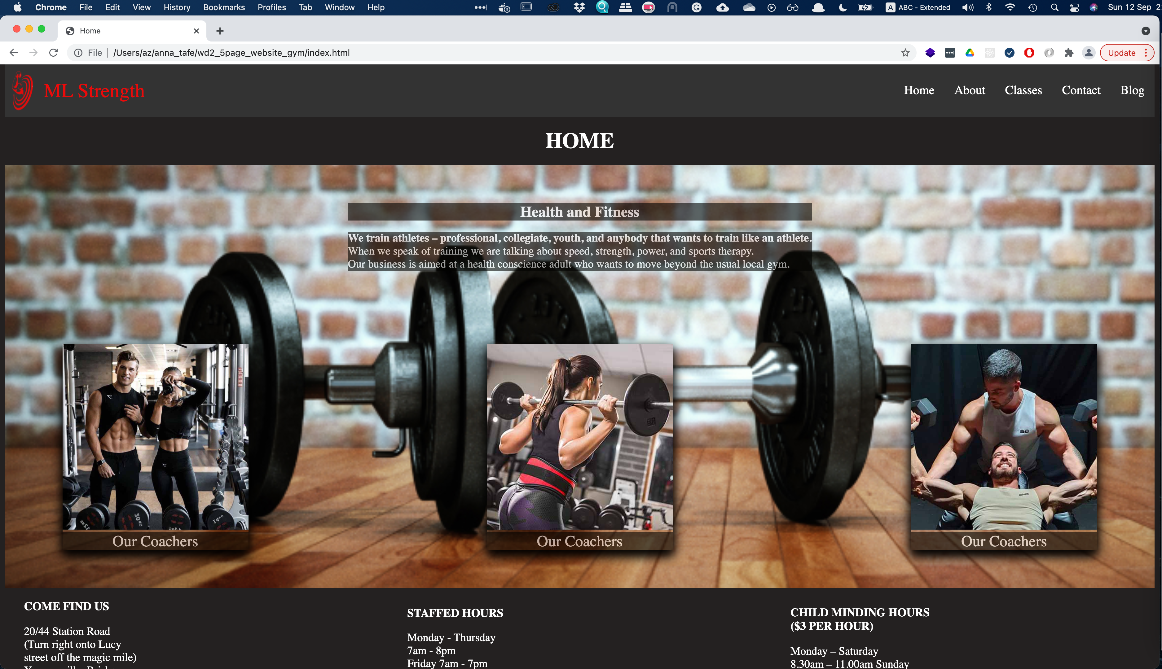
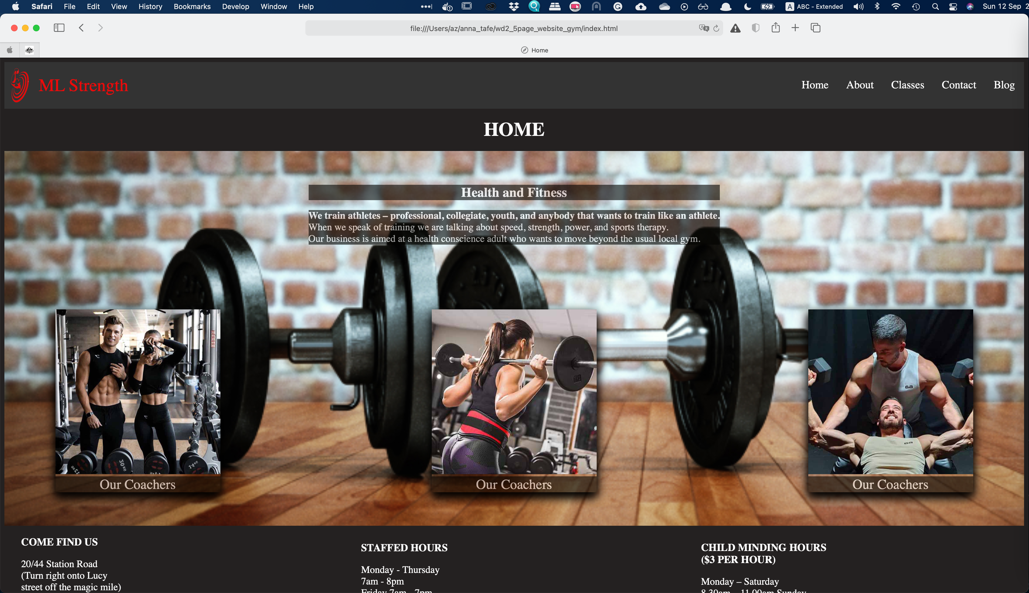

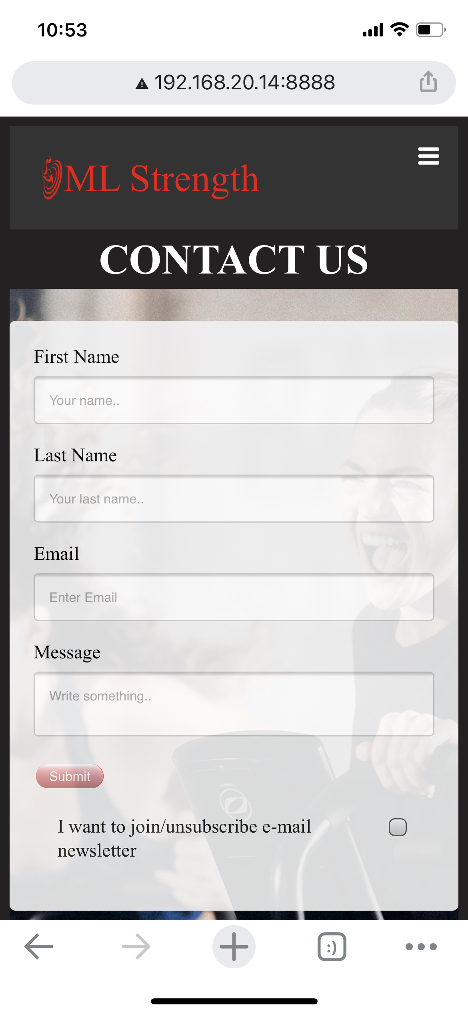

W3c validation

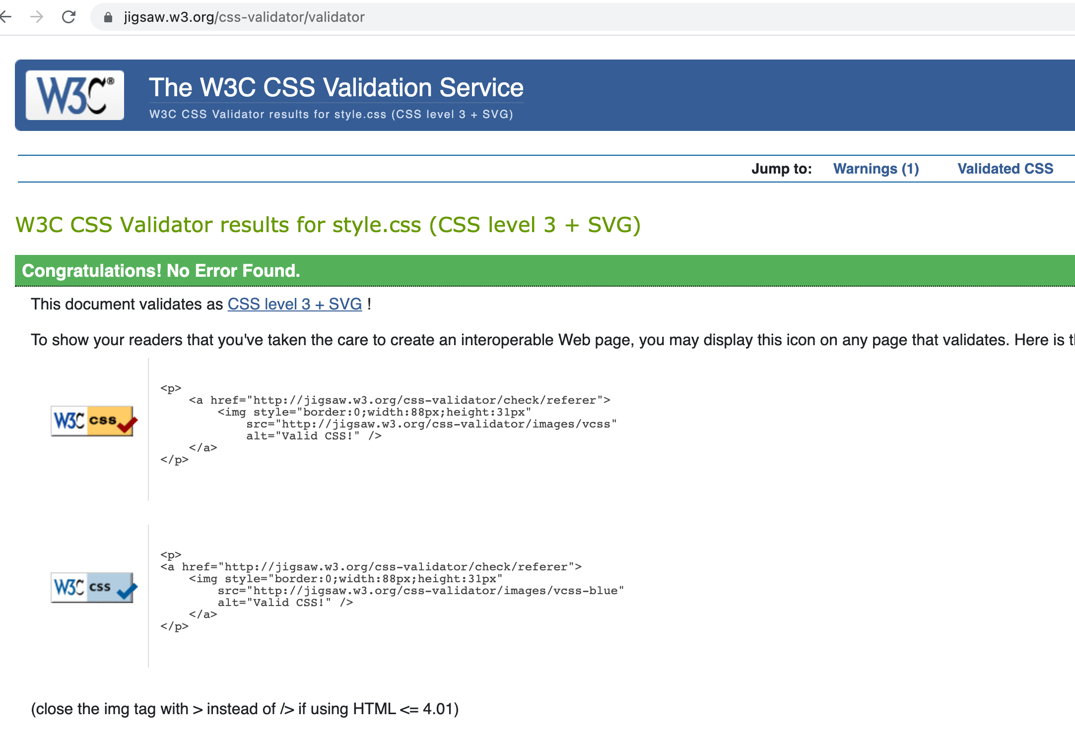

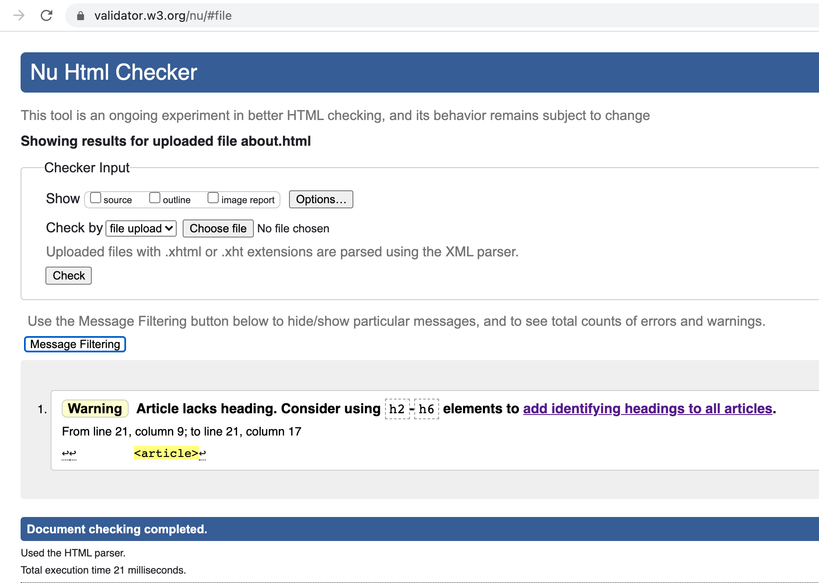
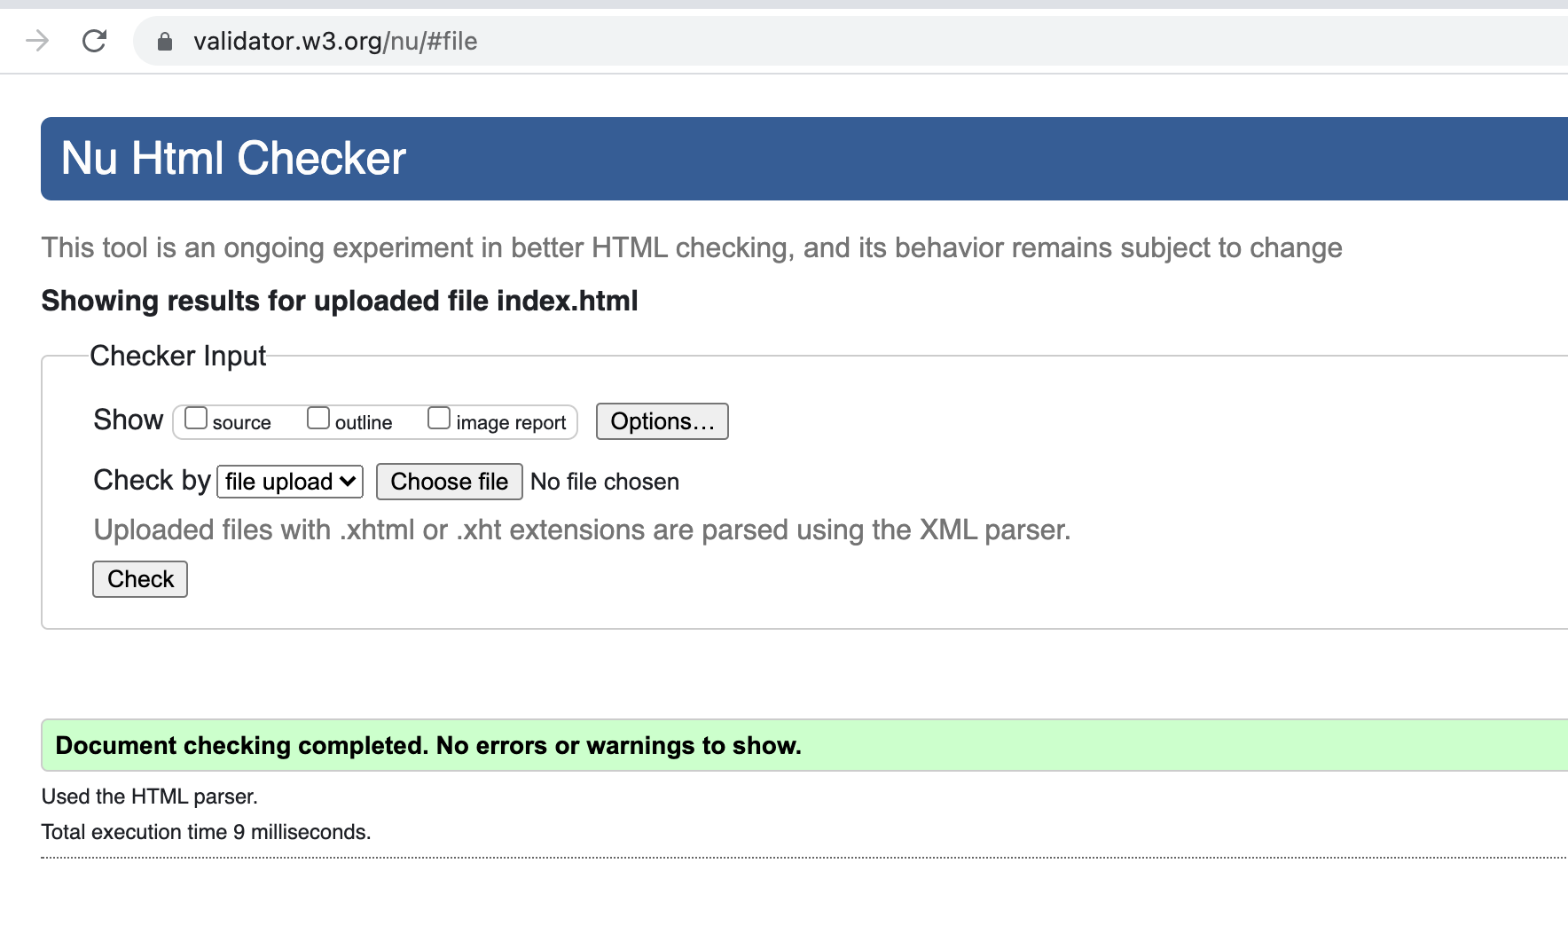

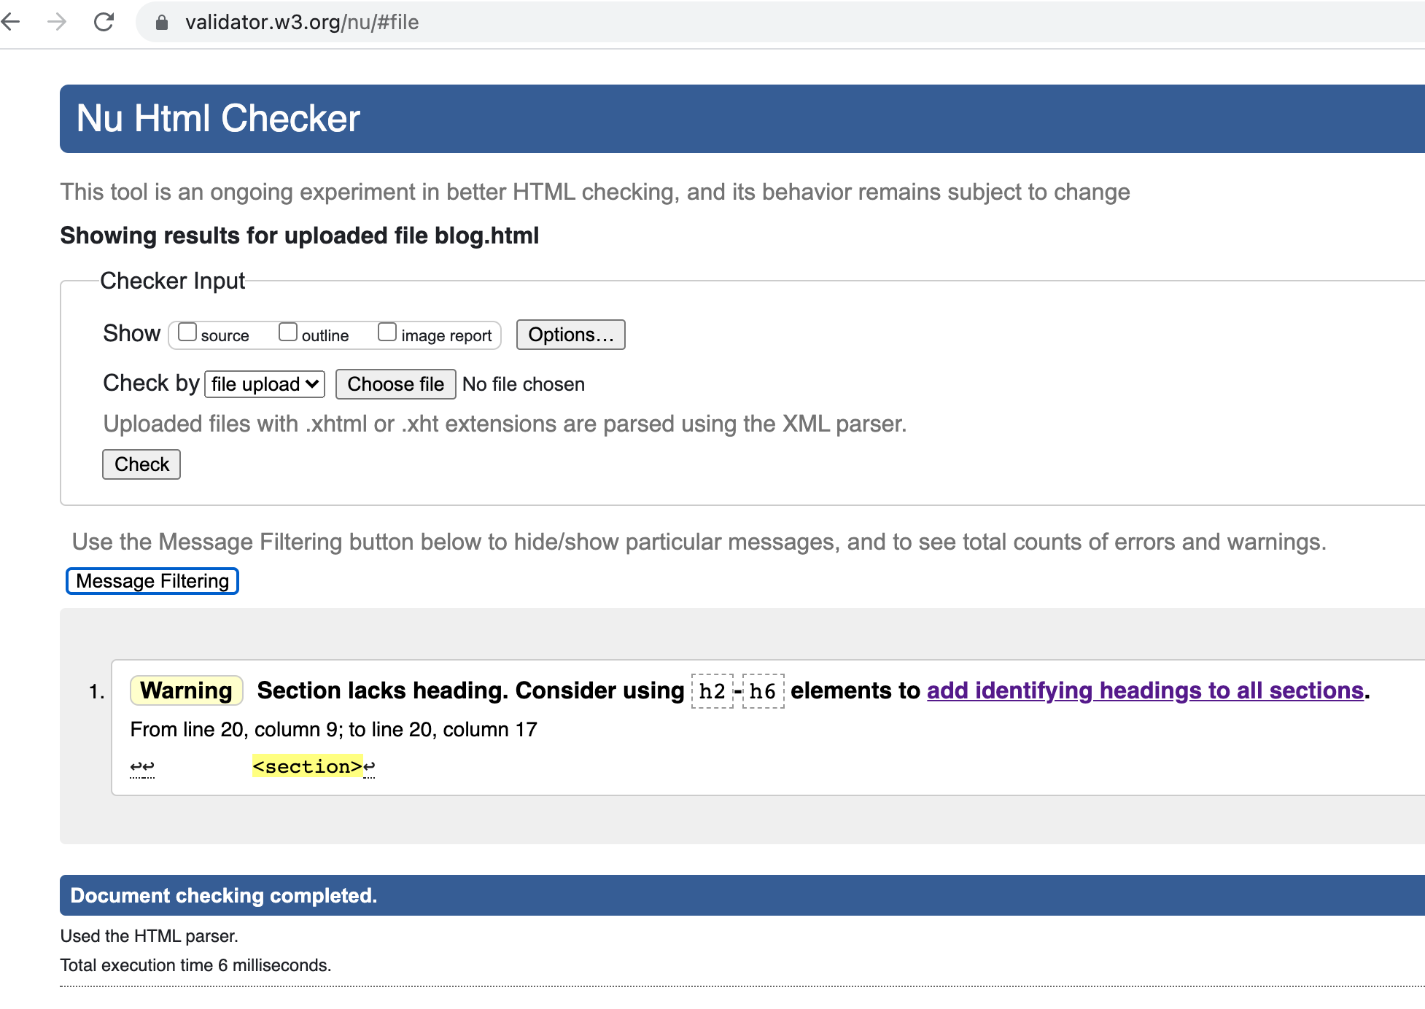
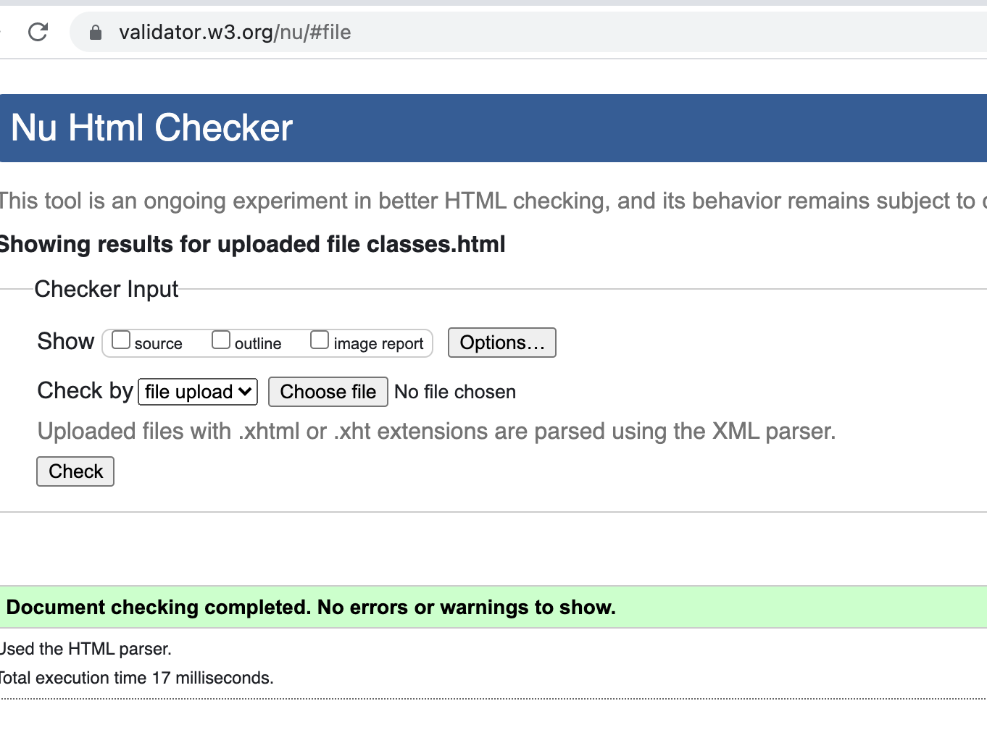

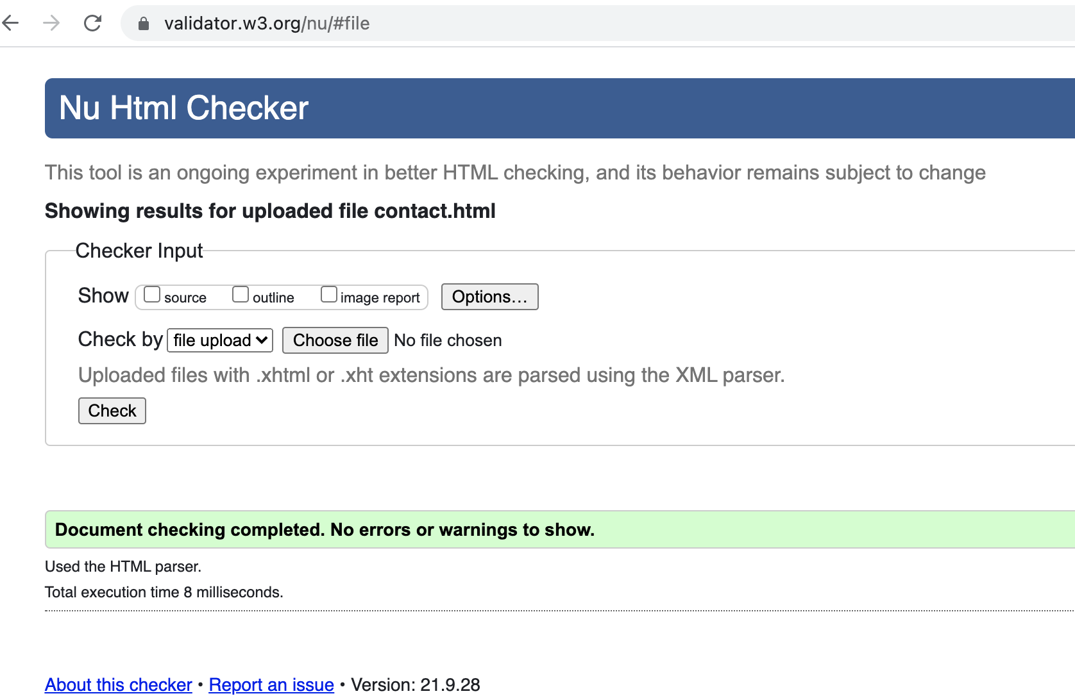

Part B
Demonstrated use of two types of CSS combinator and three pseudoclasses
I used three pseudoclasses:
a : hover
a : active
input : checked

Part C
One example of a composited image created from at least two images
I combined two images man_ropes.jpg and woman_red.jpg using Photoshop and added the composed image on the page ABOUT.

